Appendix B

The University Lab: Conceptual Design

Discussion Focus

What actions are taken during the database initial study, and why are those actions important to the database designer?

NOTE
We recommend that you use Appendix B’s Table B.1, “A Database Design Map for the University Computer Lab (UCL),” in this and all subsequent discussions about the design process. The design procedure summary should be used as a template in all design and implementation exercises, too. Student feedback indicates that this blueprint is especially helpful when it is used in conjunction with class projects. Use Appendix B’s Figure B.4, “The ER Model Segment for Business Rule 1,” to illustrate how the database design map was used to generate the initial ER diagram.

The database initial study is essentially a process based on data gathering and analysis. Carefully conducted and systematic interviews usually constitute an important part of this process.

The initial study must take its cues from an organization's key end users. Therefore, one of the first initial study tasks is to establish who the organization's key end users are. Once the key end users are identified, the initial study must be conducted to establish the following outputs:
- objectives
- organizational structure
- description of operations
- definition of problems and constraints
- description of system objectives
- definition of system scope and boundaries

The database designer cannot expect to develop a usable design unless these outputs are carefully defined and delineated. The importance of having such a list of outputs is self-explanatory. For example, a database design is not likely to be useful unless and until it accomplishes specific objectives and helps solve an organization's problems. The inherent assumption is that those problems are usually based on the lack of useful and timely information.

The value of having such a list of required outputs is clear, too, because this list constitutes a checklist to be used by the database designer. The designer should not proceed with the database design until all the items on this list have been completed.

What is the purpose of the conceptual design phase, and what is its end product?

The conceptual design phase is the first of three database design phases: conceptual, logical, and physical. The purpose of the conceptual design phase is to develop the following outputs:
- information sources and users
- Information needs: user requirements
- the initial ER model
- the definition of attributes and domains

The conceptual design's end product is the initial ER diagram, which constitutes the preliminary database blueprint. It is very unlikely that useful logical and physical designs can be produced unless and until this blueprint has been completed.

Too much "design" activity takes place without the benefit of a carefully developed database blueprint. Implementing a database without a good database blueprint almost invariably produces a lack of data integrity based on various data anomalies. In fact, it may easily be argued that implementing a successful database without a good database blueprint is just as likely as writing a great book by stringing randomly selected words together.

Why is an initial ER model not likely to be the basis for the implementation of the database?

ER modeling is an iterative process. The initial ER model may establish many of the appropriate entities and relationships, but it may be impossible to implement such relationships. Also, given the nature of the ER modeling process, it is very likely that the end users begin to develop a greater understanding of their organization's operations, thus making it possible to establish additional entities and relationships. In fact, it may be argued that one very important benefit of ER modeling is based on the fact that it is an outstanding communications tool. In any case, before the ER model can be implemented, it must be carefully verified with respect to the business transactions and information requirements. (Note that students will learn how to develop the verification process in Appendix C.)

Clearly, unless and until the ER model accurately reflects an organization's operations and requirements, the development of logical and physical designs is premature. After all, the database implementation is only as good as the final ER blueprint allows it to be!

Answers to Review Questions

1. What factors relevant to database design are uncovered during the initial study phase?

The database initial study phase yields the information required to determine an organization's needs, as well as the factors that influence data generation, collection, and processing. Students must understand that this phase is generally concurrent with the planning phase of the SDLC and that, therefore, several of the initial study activities are common to both.

The most important discovery of the initial study phase is the set of the company's objectives. Once the designer has a clear understanding of the company's main goals and its mission, (s)he can use this as the guide to making all subsequent decisions concerning the analysis, design, and implementation of the database and the information system.

The initial study phase also establishes the company's organizational structure; the description of operations, problems and constraints, alternate solutions; system objectives; and the proposed system scope and boundaries.

The organizational structure and the description of operations are interdependent because operations are usually a function of the company's organizational structure. The determination of structure and operations allows the designer to analyze the existing system and to describe a set of problems, constraints, and possible solutions.

Naturally, the designer must find a feasible solution within the existing constraints. In most cases, the best solution is not necessarily the most feasible one. The constraints also force the designer to narrow the focus on very specific problems that must be solved.

In short, the combination of all the factors we have just discussed help the designer to put together a set of realistic, achievable, and measurable system objectives within the system's required scope and boundaries.

2. Why is the organizational structure relevant to the database designer?

The delivery of information must be timely, it must reach the right people, and the delivered information must be accurate. Since the proper use of timely and accurate information is the key factor in the success of any system, the reports and queries drawn from the database must reach the key decision makers within the organization. Clearly, understanding the organization structure helps the designer to define the organization's lines of communication and to establish reporting requirements.

3. What is the difference between the database design scope and its boundaries? Why is the scope and boundary statement so important to the database designer?

The system's boundaries are the limits imposed on the database design by external constraints such as available budget and time, the current level of technology, end-user resistance to change, and so on. The scope of a database defines the extent of the database design coverage and reflects a conscious decision to include some things and exclude others. Note that the existence of boundaries usually has an effect on the system's scope.

For legal and practical design reasons, the designer cannot afford to work on an unbounded system. If the system's limits have not been adequately defined, the designer may be legally required to expand the system indefinitely. Moreover, an unbounded system will not contain the built-in constraints that make its use practical in a real-world environment. For example, a completely unbounded system will never be completed, nor may it ever be ready for reasonable use. Even a system with an "optimistic" set of bounds may drag the design out over many years and may cost too much. Keep in mind that company managers almost invariably want least-cost solutions to specific problems.

4. What business rule(s) and relationships can be described for the ERD in Figure QB.4?

Figure QB.4 The ERD for Question 4
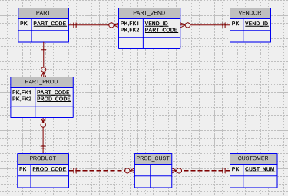

The business rules and relationships are summarized in Table QB.4

Table QB.4 Business Rules and Relationships Summary
Business rules | Relationships
A supplier supplies many parts.  Each part is supplied by many suppliers. | many to many  PART - SUPPLIER
A part is used in many products.  Each product is composed of many parts. | many to many  PRODUCT - PART
A product is bought by many customers.  Each customer buys many products. | many to many  PRODUCT - CUSTOMER

Note that the ERD in Figure QB.4 uses the PART_PROD, PROD_VEND and PROD_CUST entities to convert the M:N relationships to a series of 1:M relationships. Also, note the use of two composite entities:
- The PART_VEND entity’s composite PK is VEND_ID + PART_CODE.
- The PART_PROD entity’s composite PK is, PART_CODE + PROD_CODE.
The use of these composite PKs means that the relationship between PART and PART_VEND is strong, as is the relationship between VENDOR and PART_VEND. These strong relationships are indicated through the use of a solid relationship line.

No PK has been indicated for the PROD_CUST entity, but the existence of weak relationships – note the dashed relationship lines – lets you assume that the PROD_CUST entity’s PK is not a composite one. In this case, a revision of the ERD might include the establishment of a composite PK (PROD_CODE + CUST_NUM) for the PROD_CUST entity. (If you are using Microsoft Visio Professional, declaring the relationships between CUSTOMER and PROD_CUST and between PRODUCT and PROD_CUST to be strong will automatically generate the composite PK (PROD_CODE + CUST_NUM.)

5. Write the connectivity and cardinality for each of the entities shown in Question 4.

We have indicated the connectivities and cardinalities in Figure QB.5. (The Crow’s Foot ERD combines the connectivity and cardinality depiction through the use of the relationship symbols. Therefore, the use of text boxes – we have created those with the Visio text tool -- to indicate connectivities and cardinalities is technically redundant.)

Figure QB.5 Connectivities and Cardinalities
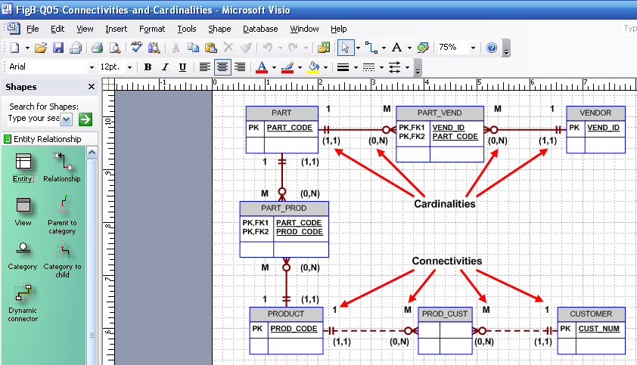

Figure QB.5’s connectivities and cardinalities are reflected in the business rules:
- One part can be supplied by one or more suppliers, and a supplier can supply many parts.
- A product is made up of several parts, and a part can be a component of different products.
- A product can be bought by several customers, and a customer can purchase several products.

6. What is a module, and what role does a module play within the system?

A module is a separate and independent collection of application programs that covers a given operational area within an information system. A module accomplishes a specific system function, and it is, therefore, a component of the overall system. For example, a system designed for a retail company may be composed of the modules shown in Figure QB.6.

Figure QB.6 The Retail Company System Modules
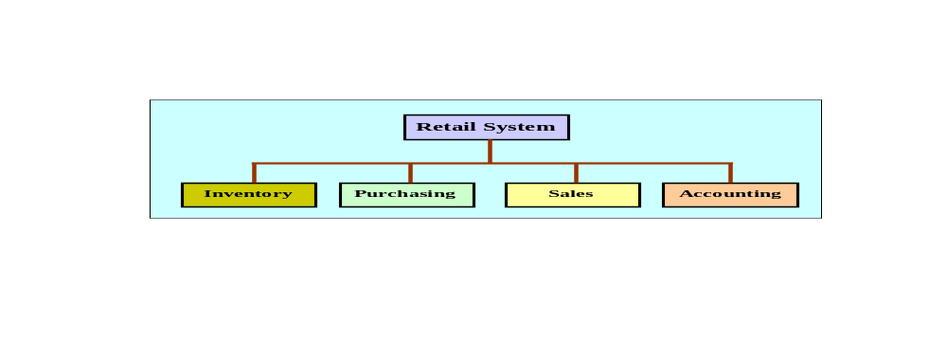

Within Figure QB.6’s Retail System, each module addresses specific functions. For example:
- The inventory module registers any new item, monitors quantity on hand, reorder quantity, location, etc.
- The purchasing module registers the orders sent to the suppliers, any supplier information, order status, etc.
- The sales module covers the sales of items to customers, generates the sales slips (invoices), credit sales checks, etc.
- The accounting module covers accounts payable, accounts receivable, and generates appropriate financial status reports.

The example demonstrates that each module has a specific purpose and operates on a database subset (external view). Each external view represents the entities of interest for the specific module. However, an entity set may be shared by several modules.

7. What is a module interface, and what does it accomplish?

A module interface is the method through which modules are connected and by which they interact with one another to exchange data and status information. The definition of proper module interfaces is critical for systems development, because such interfaces establish an ordered way through which system components (modules) interchange information. If the module interfaces are not properly defined, even a collection of properly working modules will not yield a useful working system.

Problem Solutions

- Modify the initial ER diagram presented in Figure B.19 to include the following entity supertype and subtypes: The University Computer Lab USER may be a student or a faculty member.

The answer to problem 1 is included in the answer to problem 2.

- Using an ER diagram, illustrate how the change you made in problem 1 affects the relationship of the USER entity to the following entities:

LAB_USE_LOG
RESERVATION
CHECK_OUT
WITHDRAW

The new ER diagram segment will contain the supertype USER and the subtypes FACULTY and STUDENT. How the use of this supertype/subtype relationships affect the entities shown here is illustrated in the ER diagram shown in Figure PB.2a.

Figure PB.2a The Crow’s Foot ERD with Supertypes and Subtypes
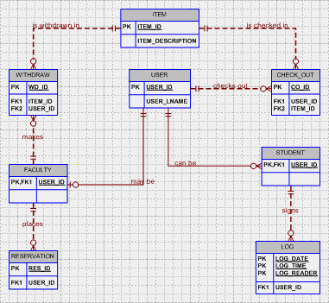

The ER segment shown in Figure PB.2a reflects the following conditions:
- Not all users are faculty members, so FACULTY is optional to USER.
- Not all users are students, so STUDENT is optional to USER.
- The conditions in the first two bullets are typical of the supertype/subtype implementation.
- Not all faculty members withdraw items, so a faculty member may not ever show up in the WITHDRAW table. Therefore, WITHDRAW is optional to FACULTY.
- Not all items are necessarily withdrawn; some are never used. Therefore WITHDRAW is optional to ITEM. (An item that is never withdrawn will never show up in the WITHDRAW table.)
- Not all items are checked out, so an ITEM may never show up in the CHECK_OUT table. Therefore, CHECK_OUT is optional to ITEM.
- Not all users check out items, so it is possible that a USER – a faculty member or a student --never shows up in the CHECK_OUT table. Therefore, CHECK_OUT is optional to USER.
- Not all faculty members place reservations, so RESERVATION is optional to FACULTY.
- Not all students use the lab, i.e., some students will never sign the log to check in. Therefore, LOG is optional to STUDENT.

Given the text’s initial development of the UCL Management System’s ERD, the USER entity was related to both the WITHDRAW and CHECK_OUT entities. Therefore, there was no way of knowing whether a STUDENT or a FACULTY member was related to WITHDRAW or CHECK_OUT. Although the business rules were quite specific about the relationships, the ER diagram did not reflect them.

By adding a new USER supertype and two STUDENT and FACULTY subtypes, the ERD more closely represents the business rules. The supertype/subtype relationship in Figure PB.2a lets us see that STUDENT is related to LOG, and that only FACULTY members can make a RESERVATION and WITHDRAW items. However, both STUDENT and FACULTY can CHECK_OUT items.

While this supertype/subtype solution conforms to the problem solution requirements, the design is far from complete. For example, one would suppose that FACULTY is already a subtype to EMPLOYEE. Also, can a faculty member also be a student? In other words, are the supertypes/subtypes overlapping or disjoint? In this initial ERD, we have assumed overlapping subtypes; that is, a user can be a faculty member and a student at the same time.

Another solution -- which would eliminate the USER/FACULTY and USER/STUDENT supertype/subtypes in the ERD – is to add an attribute, such as USER_TYPE, to the USER entity to identify the user as faculty or student. The application software can then be used to enforce the restrictions on various user types. Actually, that approach was used in the final (verified) Computerlab.mdb database on your CD. (The verified database is provided for Appendix C.)

- Create the initial ER diagram for a car dealership. The dealership sells both new and used cars, and it operates a service facility. Base your design on the following business rules:
- A salesperson can sell many cars but each car is sold by only one salesperson.
- A customer can buy many cars but each car is sold to only one customer.
- A salesperson writes a single invoice for each car sold.
- A customer gets an invoice for each car (s)he buys.
- A customer might come in just to have a car serviced; that is, one need not buy a car to be classified as a customer.
- When a customer takes one or more cars in for repair or service, one service ticket is written for each car.
- The car dealership maintains a service history for each car serviced. The service records are referenced by the car's serial number.
- A car brought in for service can be worked on by many mechanics, and each mechanic may work on many cars.
- A car that is serviced may or may not need parts. (For example, parts are not necessary to adjust a carburetor or to clean a fuel injector nozzle.)

As you examine the initial ERD in Figure PB.3a, note that business rules (a) through (d) refer to the relationships of four main entities in the database: SALESPERSON, INVOICE, CUSTOMER, and CAR. Note also that an INVOICE requires a SALESPERSON, a CUSTOMER, and a CAR. Business rule (e) indicates that INVOICE is optional to CUSTOMER and CAR because a CAR is not necessarily sold to a CUSTOMER. (Some customers only have their cars serviced.)

The position of the CAR entity and its relationships to the CUSTOMER and INV_LINE entities is subject to discussion. If the dealer sells the CAR, the CAR entity is clearly related to the INV_LINE that is related to the INVOICE. (If the car is sold, it generates one invoice line on the invoice. However, the invoice is likely to contain additional invoice lines, such as a dealer preparation charge, destination charge, and so on.) At this point, the discussion can proceed in different directions:
- The sold car can be linked to the customer through the invoice. Therefore, the relationship between CUSTOMER and CAR shown in Figures PB.3a and PB.3b is not necessary.
- If the customer brings a car in for service – whether or not that car was bought at the dealer – the relationship between CUSTOMER and CAR is desirable. After all, when a service ticket is written in the SERVICE_LOG, it would be nice to be able to link the customer to the subsequent transaction. More important, it is the customer who gets the invoice for the service charge. However, if the CUSTOMER-CAR relationship is to be retained, it will be appropriate to make a distinction between the cars in the dealership’s inventory – which are not related to a customer at that point – and the cars that are owned by customers. If no distinction is made between customer-owned cars and cars still in the dealership inventory, Figure PB.3a’s CAR entity will either have a null CUST_NUM or the customer entity must contain a dummy record to indicate a “no customer – dealer-owned” condition.

Figure PB.3a The Car Dealership Initial Crow’s Foot ERD
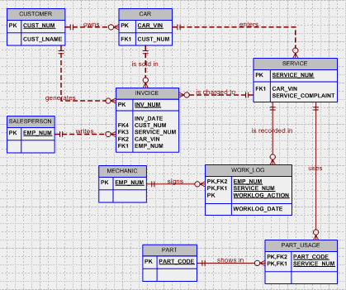

Regardless of which argument “wins” in the presentation of the various scenarios, remind the students that the ERD to be developed in this exercise is to reflect the initial design. More important, such discussions clearly indicate the need for very detailed descriptions of operations and the development of precisely written business rules. (It may be useful to review that business rules, which are derived from the description of operations, are written to help define entities, relationships, constraints, connectivities, and cardinalities.)

The dealer’s service function is likely to be crucial to the dealer – good service helps generate future sales and the service function is very likely an important cash flow generator. Therefore, the CAR entity plays an important role. If a customer brings in a car for service and the car was not bought at the dealership, it must be added to the CAR table in order to enable the system to keep a record of the service. This is why we have depicted the CUSTOMER – owns - CAR relationship in Figures PB.3a and PB.3b. Also, note that the optionality next to CAR reflects the fact that not all cars are owned by a customer: Some cars belong to the dealership.

Because Figure PB.3a shows the initial ERD, that ERD will be subject to revision as the description of operations becomes more detailed and accurate, thus modifying some of the existing business rules and creating additional business rules. Therefore, additional entities and relationships are likely to be developed and some optional relationships may become mandatory, while some mandatory relationships may become optional. Additional changes are likely to be generated by normalization procedures. Finally, the initial design includes some features that require fine-tuning. For example, a SALESPERSON is just another kind of EMPLOYEE – perhaps the main difference between “general” employee and a sales person is that the latter requires tracking of sales performance for commission and/or bonus purposes. Therefore, EMPLOYEE would be the supertype and SALESPERSON the subtype. All these issues must be addressed in the verification and logical design phases addressed in Appendix E.

Incidentally, your students may ask why the design does not show a HISTORY entity. The reason for is absence is that the car’s history can be traced through the SERVICE entity.

NOTE
Although we are generally reluctant to make forward references, you may find it very useful to look ahead to the ERD shown in Appendix C’s Figure PC.1a. The discussion that precedes the presentation of the modified ERD is especially valuable – students often find such sample data to be the key to understanding a complex design. In any case, the modified ERD in Figure PC.1a provides ample evidence that the initial ERD is only a starting point for the design process.

As you discuss the design shown in Figure PB.3a, note that it is far from implementation-ready. For example,
- The INVOICE is likely to contain multiple charges, yet it is only capable of handling one charge at a time at this point. The addition of an INV_LINE entity is clearly an excellent idea.
- The SERVICE entity has some severe limitations caused by the lack of a SERVICE_LINE entity. (Note the previous point.) Given this design, it is impossible to store and track all the individual service (maintenance) procedures that are generated by a single service request. For example, a 50,000 mile check may involve multiple procedures such as belt replacements, tire rotation, tire balancing, brake service, and so on. Therefore, the SERVICE entity, like the INVOICE entity, must be related to service lines, each one of which details a specific maintenance procedure.
- The PART_USAGE entity’s function is rather limited. For example, its depiction as a composite entity does properly translate the notion that a part can be used in many service procedures and a service procedure can use many parts. Unfortunately, the lack of a SERVICE_LINE entity means that we cannot track the parts use to a particular maintenance procedure.
- According to business rule (d), the relationship between CAR and INVOICE would be 1:1. However, if it is possible for the dealer to take the car in trade at a later date and subsequently sells it again, the same CAR_VIN value may appear in INVOICE more than once. We have depicted the latter scenario.

The initial design does have one very nice feature at this point: The existence of the WORK_LOG entity’s WORKLOG_ACTION attribute makes it possible to record which mechanic started the service procedure and which one ended the procedure. (The WORKLOG_ACTION attribute has only two values, open and close.) Note that this feature eliminates the need for a null ending date in the SERVICE entity while the car is being serviced. Better yet, if we need to be able to track which mechanics opened and closed the service procedure, the WORK_LOG entity’s presence eliminates the need for synonyms in the SERVICE entity. Note, for example, that the following few sample entries in the WORK_LOG table lets us conclude that service number 12345 was opened by mechanic 104 on 10-Mar-2014 and closed by the same mechanic on 11-Mar-2014.

Table PB.3 Sample Data Entries in the WORK_LOG Entity
EMP_NUM | SERVICE_NUM | WORKLOG_ACTION | WORKLOG_DATE
104 | 12345 | OPEN | 10-Mar-2014
107 | 12346 | OPEN | 10-Mar-2014
104 | 12345 | CLOSE | 11-Mar-2014
104 | 12346 | CLOSE | 11-Mar-2014
112 | 12347 | OPEN | 11-Mar-2014

The format you see in Table PB.3 is based on a standard we developed for aviation maintenance databases. Because almost all aspects of aviation are tightly regulated, accountability is always close to the top of the list of design requirements. (In this case, we must be able to find out who opened the maintenance procedure and who closed it.) You will discover in Chapter 9, “Database Design,” that we will apply the accountability standard to other aspects of the design, too. (Who performed each maintenance procedure? Who signed out the part(s) used in each maintenance procedure? And so on.)

It is worth repeating that a discussion of the shortcomings of the initial design will set an excellent stage for the introduction of Appendix C’s verification process.

Strict accountability standards are becoming the rule in many areas outside aviation. Such standards may be triggered by legislation or by company operations in an increasingly litigious environment.

- Create the initial ER diagram for a video rental shop. Use (at least) the following description of operations on which to base your business rules.

The video rental shop classifies movie titles according to their type: Comedy, Western, Classical, Science Fiction, Cartoon, Action, Musical, and New Release. Each type contains many possible titles, and most titles within a type are available in multiple copies. For example, note the summary presented in Table PB.4:

Table PB.4 The Video Rental Type and Title Relationship
TYPE | TITLE | COPY
Musical | My Fair Lady  My Fair Lady  Oklahoma!  Oklahoma!  Oklahoma! | 1  2  1  2  3
Cartoon | Dilly Dally & Chit Chat Cat  Dilly Dally & Chit Chat Cat  Dilly Dally & Chit Chat Cat | 1  2  3
Action | Amazon Journey  Amazon Journey | 1  2

Keep the following conditions in mind as you design the video rental database:
- The movie type classification is standard; not all types are necessarily in stock.
- The movie list is updated as necessary; however, a movie on that list might not be ordered if the video shop owner decides that it the movie is not desirable for some reason.
- The video rental shop does not necessarily order movies from all of the vendor list; some vendors on the vendor list are merely potential vendors from whom movies may be ordered in the future.
- Movies classified as new releases are reclassified to an appropriate type after they have been in stock for more than 30 days. The video shop manager wants to have an end-of- period (week, month, year) report for the number of rentals by type.
- If a customer requests a title, the clerk must be able to find it quickly. When a customer selects one or more titles, an invoice is written. Each invoice may thus contain charges for one or more titles. All customers pay in cash.
- When the customer checks out a title, a record is kept of the checkout date and time and the expected return date and time. Upon the return of rented titles, the clerk must be able to check quickly whether the return is late and to assess the appropriate late return fee.
- The video-store owner wants to be able to generate periodic revenue reports by title and by type. The owner also wants to be able to generate periodic inventory reports and to keep track of titles on order.
- The video-store owner, who employs two (salaried) full-time and three (hourly) part-time employees, wants to keep track of all employee work time and payroll data. Part-time employees must arrange entries in a work schedule, while all employees sign in and out on a work log.

NOTE
The description of operations not only establishes the operational aspects of the business; it also establishes some specific system objectives we have listed next.

As you design this database, remember that transaction and information requirements help drive the design by defining required entities, relationships, and attributes. Also, keep in mind that the description provided by the problem leaves many possibilities for design differences. For example, consider the EMPLOYEE classification as full-time or part-time. If there are few distinguishing characteristics between the two, the situation may be handled by using an attribute EMP_CLASS (whose values might be F or P) in the EMPLOYEE table. If full-time employees earn a base salary and part-time employees earn only an hourly wage, that problem can be handled by having two attributes, EMP_HOURPAY and EMP_BASE_PAY, in EMPLOYEE. Using this approach, the HOUR_PAY would be $0.00 for the salaried full-time employees, while the EMP_BASE_PAY would be $0.00 for the part-time employees. (To ensure correct pay computations, the application software would select either F or P, depending on the employee classification.) On the other hand, if part-time employees are handled quite differently from full-time employees in terms of work scheduling, benefits, and so on, it would be better to use a supertype/subtype classification for FULL_TIME and PART_TIME employees. (The more unique variables exist, the more sense a supertype/subtype relationship makes.)

For discussion purposes, examine the following requirements:
- The clerk must be able to find customer's requests quickly.
- This requirement is met by creating an easy way to query the MOVIE data (by name, type, etc.) while entering the RENTAL data.
- The clerk must be able to check quickly whether or not the return is late and to assess the appropriate “late return” fee. This requirement is met by adding attributes such as expected return date, actual return date, and late fees to the RENTAL entity. Note that there is no need to add a new entity, nor do we need to create an additional relationship. Keep in mind that some requirements are easily met by including the appropriate attributes in the tables and by combining those attributes through an application program that enforces the business rule. Remember that not all business rules can be represented in the database conceptual diagram.
- The (store owner) wants to be able to keep track of all employee work time and payroll data.
- Here we must create two new entities: WORK_SCHEDULE and WORK_LOG, which will show the employee's work schedule and the actual times worked, respectively. These entities will also help us generate the payroll report.

The description also specifies some of the expected reports:
- End-of-period report for the number of rentals by type. This report will use the RENTAL, MOVIE, and TYPE entities to generate all rental data for some specified period of time.
- Revenue report by title and by type. This report will use the RENTAL, MOVIE, and TYPE entities to generate all the rental data.
- Periodic inventory reports. This report will use the MOVIE and TYPE entities.
- Titles on order. This report will use the ORDER, MOVIE, and TYPE entities.
- Employee work times and payroll data. This report will use the EMPLOYEE, WORK_SCHEDULE, and WORK_LOG entities.

This summary sets the stage for the ERD shown in Figure PB.4a. Note that the WORK_SCHEDULE and WORK_LOG entities are optional to EMPLOYEE. The optionalities reflect the following conditions:
- Only part-time employees have corresponding records in the work log table.
- Only full-time employees have corresponding records in the work schedule table.

Although there is a temptation to create FULL_TIME and PART_TIME entities, which are then related to WORK_LOG and WORK_SCHEDULE, respectively, such a decision reflects a substitution of an entity for an attribute. It is far better to simply create an attribute, perhaps named EMP_TYPE, in the EMPLOYEE entity. The EMP_TYPE attribute values would then be P = part-time or F = full-time. The applications software can then be used to force an entry into the WORK_LOG and WORK_SCHEDULE entities, depending on the EMP_TYPE attribute value.

Student question: Using the argument just presented, what other entity might be replaced by an attribute? Answer: The TYPE entity can be represented by a TITLE_TYPE attribute in the TITLE entity. The TITLE_TYPE values would then be “Western”, “Adventure”, and so on. This approach works fine, as long as the type values don’t require additional descriptive material. In the latter case, the TYPE would be better represented by an entity in order to avoid data redundancy problems.

Figure PB.4a The Initial Crow’s Foot ERD for the Video Rental Store
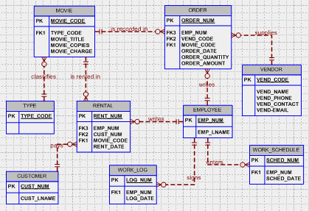

Additional discussion: At this point, the ERD has not yet been verified against the transaction requirements. For example, there is no way to check which specific video has been rented by a customer. (If five customers rent copies of the same video, you don’t know which customer has which copy.) Therefore, the design requires additional work triggered by the verification process.

In addition, the work log entity’s LOG_DATE is incapable of tracking when the part-time employees logged in or out. Therefore, two dates must be used, perhaps named LOG_DATE_IN and LOG_DATE_OUT. In addition, if you want to determine the hours worked by each part-time employee, it will be necessary to record the time in and time out.

Similarly, the work schedule cannot yet be used to track the full-time employees’ schedules. Who has worked and when? Clearly, the verification process discussed in Appendix C is not a luxury!

- Suppose a manufacturer produces three high-cost, low-volume products: P1, P2, and P3. Product P1 is assembled with components C1 and C2; product P2 is assembled with components C1, C3, and C4; and product P3 is assembled with components C2 and C3. Components may be purchased from several vendors, as shown in Table PB.5:

Table PB.5 The Component/Vendor Summary
VENDOR | COMPONENTS SUPPLIED
V1 | C1, C2
V2 | C1, C2, C3, C4
V3 | C1, C2, C4

Each product has a unique serial number, as does each component. To keep track of product performance, careful records are kept to ensure that each product's components can be traced to the component supplier.

Products are sold directly to final customers; that is, no wholesale operations are permitted. The sales records include the customer identification and the product serial number.
Using the preceding information, do the following:

- Write the business rules governing the production and sale of the products.

The business rules are summarized in Figure PB.5A.

Figure PB.5A The Business Rule Summary
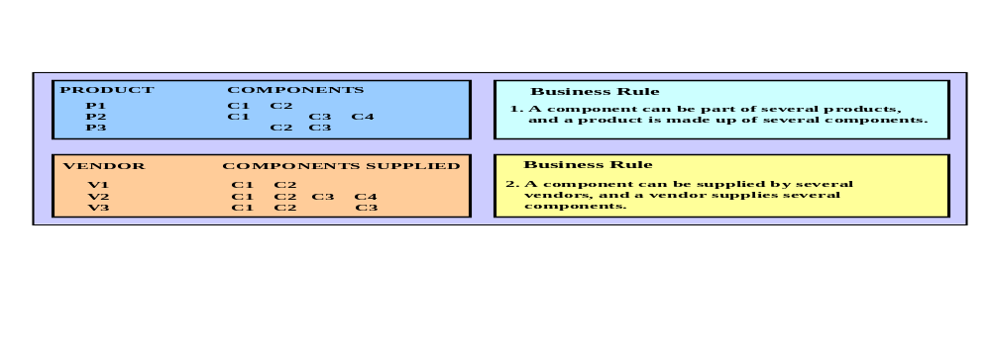

- Create an ER diagram capable of supporting the manufacturer's product/component tracking requirements.

The two business rules shown in Figure PB.5A allow the designer to generate the ERD Shown in Figure PB.5B1. (Note the M:N relationships between PRODUCT and COMPONENT and between COMPONENT and VENDOR that have been converted through the composite entities PROD_COMP and COMP_VENB.)

Figure PB.5B1 The Initial Crow’s Foot ERD for Problem B.5B
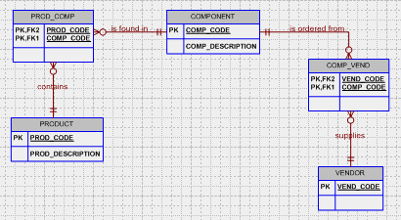

As you examine Figure PD5.B1, note that we have use default optionalities in the composite entities named PROD_COMP and COMP_VENB. Naturally, these optionalities must be verified against the business rules before the design is implemented. However, at this point the optionalities make sense – after all, various version of a PRODUCT do not necessarily contain all available COMPONENTs, not do all VENDORs supply all COMPONENTs. Quite aside from the likely existence of the relationships we just pointed out, optionalities are generally desirable from an operational point of view – at least from the database management angle. Yet, no matter how “obvious” a relationship may appear to be, it is worth repeating that the existence of the optionalities must be verified. Designs that do not reflect the actual data environment are not likely to be useful at the end user level.

Given the ERDs in Figures PB.5B1 and PB.B2, you can see that each PRODUCT entry actually represents a product line, i.e., a collection of products belonging to the same product type or line, rather than a specific product occurrence with a unique serial number. Therefore, this model will not enable us to identify the serial number for each component used in, for example, a product with serial number 348765. Therefore, this solution does not allow us to track the provider of a part that was used in a specific PRODUCT occurrence. (Note the example in Figure PB.5C.)

Figure PB.5C An Initial Implementation
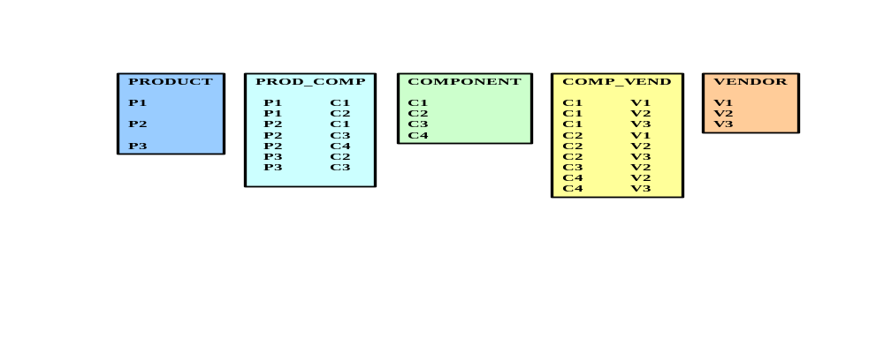

As you examine Figure PB.5C, note that there are no serial numbers for the components, nor are there any for the products produced. In other words, we do not meet the requirements imposed by:

BUSINESS RULE 3

Each product has a unique serial number. For example, there will be several products P1, each with a unique serial number. Each unique product will be composed of several components, and each of those components has a unique serial number.

The implementation of business rule 3 will allow us to keep track of the supplier of each component.

One way to produce the tracking capability required by business rule 3 is to use a ternary relationship between PRODUCT, COMPONENT, and VENDOR, shown in Figure P5.5D1:

Figure PB.5D1 The Crow’s Foot Ternary Relationship between PRODUCT,
COMPONENT, and VENDOR
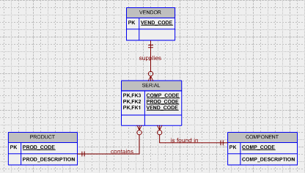

The ER diagram we have just shown represents a many-to-many-to-many TERNARY relationship, expressed by M:N:P. This ternary relationship indicates that:
- A product is composed of many components and a component appears in many products.
- A component is provided by many vendors and a vendor provides many products.
- A product contains components of many vendors and a vendor's components appear in many products.

Assigning attributes to the SERIALS entity, we may draw the dependency diagram shown in Figure P7-5E.

Figure P7-5E The Initial Dependency Diagram
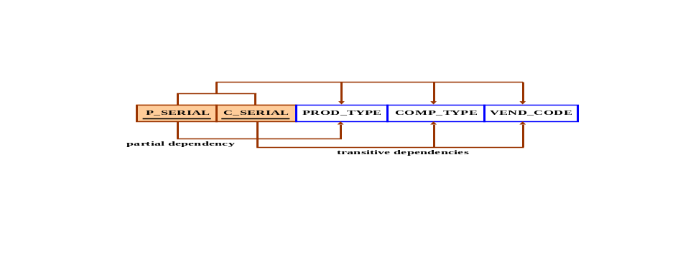

We may safely assume that all serial numbers are unique. If we make this assumption, we can conclude that the product serial number will identify the product type and that the component serial number will identify the component type and the vendor. Using the standard normalization procedures, we may thus decompose the entity as shown in the dependency diagrams in Figure PB.5F.

Figure PB.5F The Normalized Structure
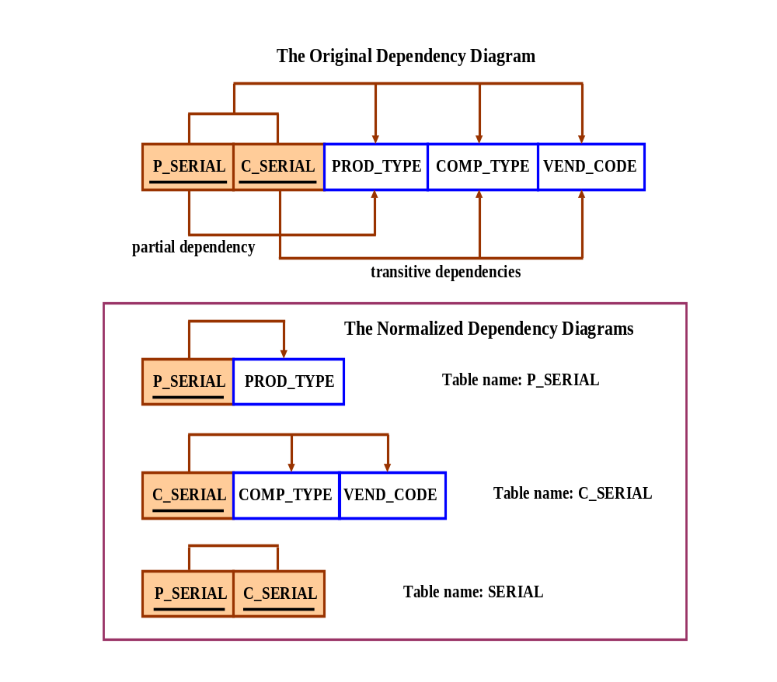

As you examine the dependency diagrams in Figure PB.5F, note the following:
- P_SERIAL has a 1:M relationship with PRODUCT, because one product has many product serial numbers.
- C_SERIAL has a 1:M relationship with COMPONENT, because one component has many component serial numbers.
- SERIAL is the composite entity that connects P_SERIAL and C_SERIAL, thus reflecting the fact that one product has many components and a component can be found in many products.

To illustrate the relationships we have just described, let's take a look at some data in Figure P7-5G:

Figure PB.5G Sample Data
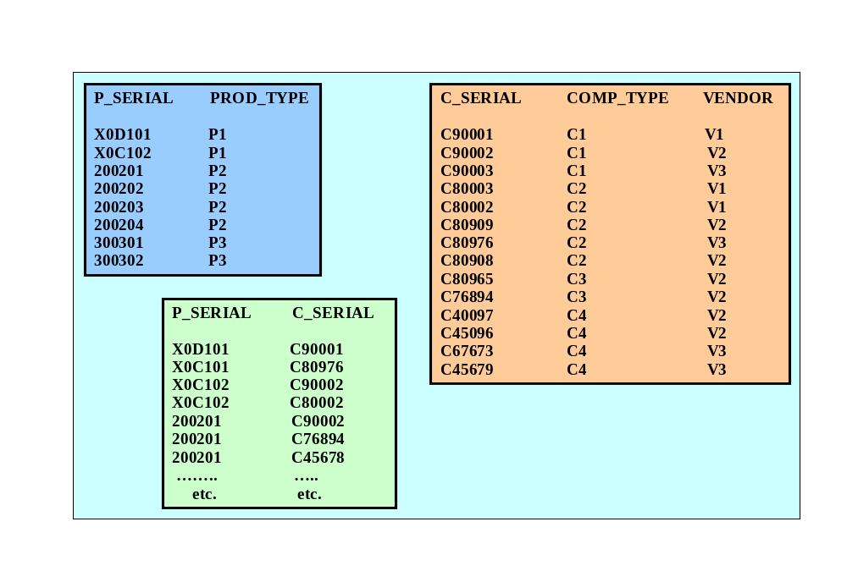

The new ER diagram will enable us to identify the product by a unique serial number, and each of the product's components will have a unique serial number, too. Therefore, the new ER diagram will look like Figure PB.5H1.

Figure PB.5H1 The Revised (Final) Crow’s Foot ERD
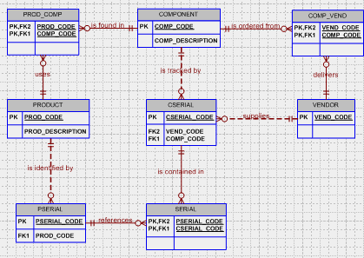

As you examine Figure PB.5H1’s ERD, note that the COMP_VEND composite entity seems redundant, because the CSERIAL entity already depicts the many-to-many relationship between VENDOR and COMPONENT. However, COMP_VEND represents a more general relationship that enables us to determine who the likely providers of the general component are (what vendors supply component C1?), rather than letting us determine a specific component's vendor (which vendor supplied the component C1 with a serial number C90003?). The designer must confer with the end user to decide whether such a general relationship is necessary or if it can be removed from the database without affecting its semantic contents.

- Create an ER diagram for a hardware store. Make sure that you cover (at least) store transactions, inventory, and personnel. Base your ER diagram on an appropriate set of business rules that you develop. (Note: It would be useful to visit a hardware store and conduct interviews to discover the type and extent of the store's operations.)

Since the problem does not specify a set of business rules, we will create some that will enable us to develop an initial ER diagram.

NOTE
Please take into consideration that, depending on the assumptions made and on the selection of business rules, students are likely to create quite different solutions to this problem. You may find it quite useful to study each student solution and to incorporate the most interesting parts of each solution into a common ER diagram. We know that this is not an easy job, but your students will benefit because you will thus enable them to develop very important analytical skills. You should stress that:
- A problem may be examined from many different angles.
- Similar organizations, using different business rules, will generate design problems that may be solved through the use of quite different solutions.

To get the class discussion started, we will assume these business rules:
- A product is provided by many suppliers, and a supplier can provide several products.
- An employee has many dependents, but a dependent can be claimed by only one employee.
- An employee can write many invoices, but each invoice is written by only one employee.
- Each invoice belongs to only one customer, and each customer owns many invoices.
- A customer makes several payments, and each payment belongs to only one customer.
- Each payment may be applied partially or totally to one or more invoices, and each invoice can be paid off in one or more payments.

Using these business rules, we may generate the ERD shown in Figure PB.6A.

Figure PB.6A The Crow’s Foot ERD for Problem 6 (The Hardware Store)
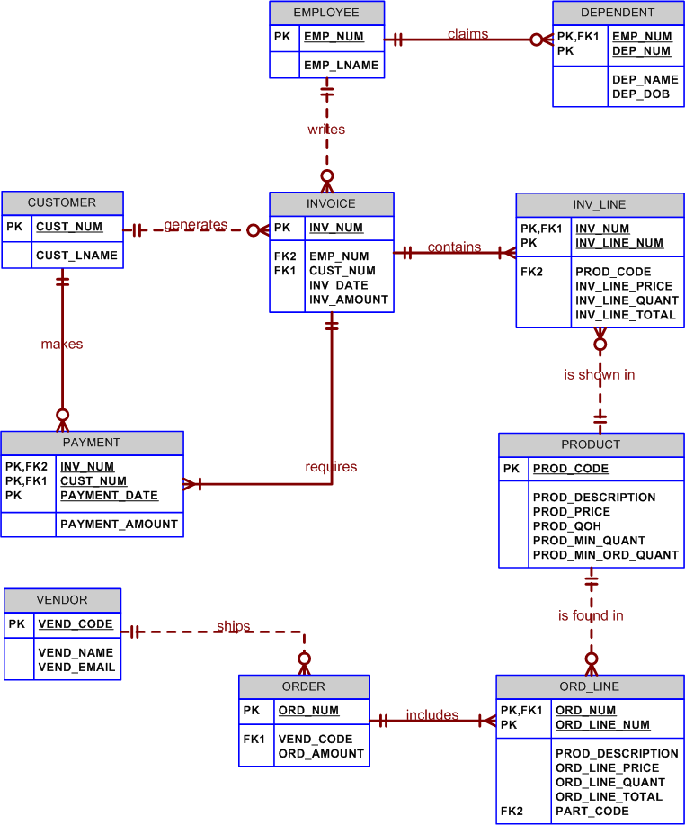
The ERD shown in Figure PB.6A requires less tweaking than the previous ERDs to get it ready for implementation. For example, given the presence of the INV_LINE entity, the customer can buy more than one product per invoice. Similarly, the ORD_LINE entity makes it possible for more than one product to be ordered per order.

However, as you examine the PAYMENT entity in Figure PB.6A, note that the current PK definition limits the payments for a given customer and invoice number to one per day. (Two payments by the same customer for the same invoice number on the same date would violate the entity integrity rules, because the two composite PK values would be identical in that scenario.) Therefore, the design shown in Figure PB.6A still requires additional work, to be completed during the verification process.

- Use the following brief description of operations as the source for the next database design:

All aircraft owned by ROBCOR require periodic maintenance. When maintenance is required, a maintenance log form is used to enter the aircraft identification number, the general nature of the maintenance, and the maintenance starting date. A sample maintenance log form is shown in Figure PB.7A.

FIGURE PB.7A The Maintenance Log Form
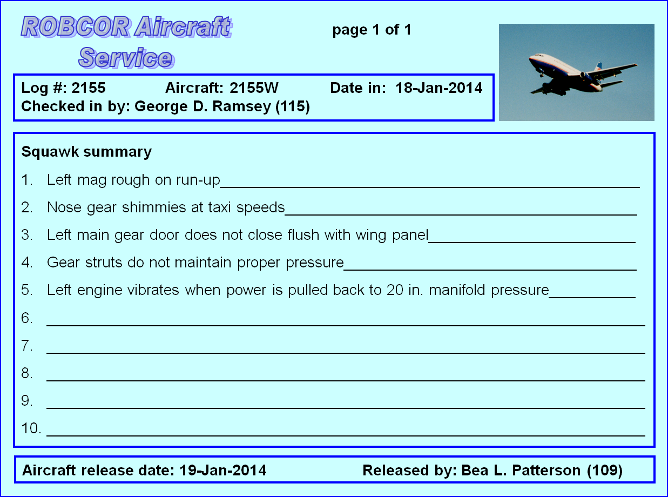
Note that the maintenance log form shown in Figure PB.7A contains a space used to enter the maintenance completion date and a signature space for the supervising mechanic who releases the aircraft back into service. Each maintenance log form is numbered sequentially. Note: A supervising mechanic is one who holds a special Federal Aviation Administration (FAA) Inspection Authorization (IA). Three of ROBCOR’s ten mechanics hold such an IA.

Once the maintenance log form is initiated, the maintenance log form’s number is written on a maintenance specification sheet, also known as a maintenance line form. When completed, the specification sheet contains the details of each maintenance action, the time required to complete the maintenance, parts (if any) used in the maintenance action, and the identification of the mechanic who performed the maintenance action. The maintenance specification sheet is the billing source (time and parts for each of the maintenance actions), and it is one of the sources through which parts use may be audited. A sample maintenance specification sheet (line form) is shown in Figure PB.7B.

FIGURE PB.7B The Maintenance Line Form
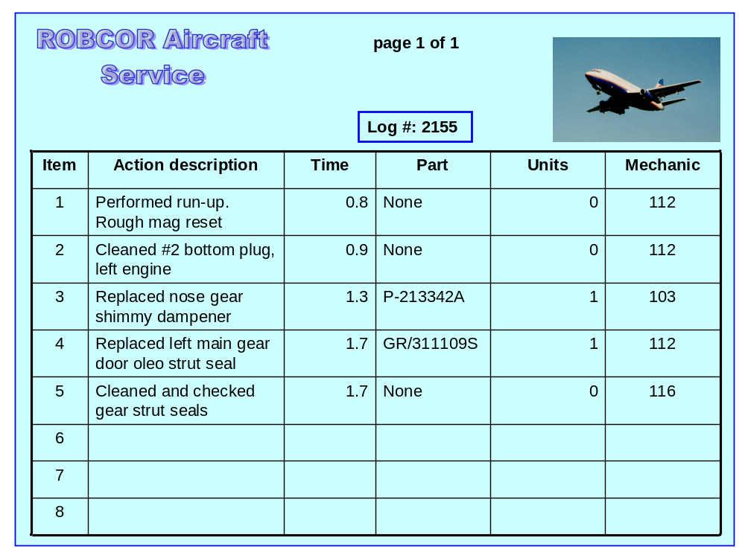

Parts used in any maintenance action must be signed out by the mechanic who used them, thus allowing ROBCOR to track its parts inventory. Each sign-out form contains a listing of all the parts associated with a given maintenance log entry. Therefore, a parts sign-out form contains the maintenance log number against which the parts are charged. In addition, the parts sign-out procedure is used to update the ROBCOR parts inventory. A sample parts sign-out form is shown in Figure PB.7C.

FIGURE PB.7C The Parts Sign-out Form
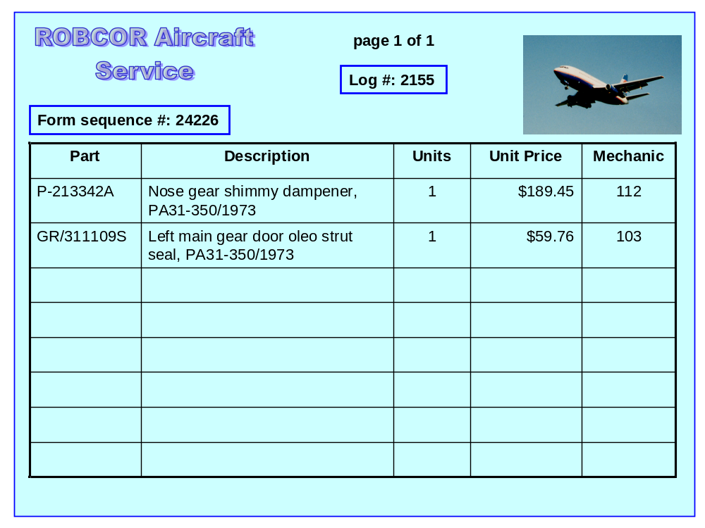

Mechanics are highly specialized ROBCOR employees, and their qualifications are quite different from those of an accountant or a secretary, for example.

Given this brief description of operations, draw the fully labeled ER diagram. Make sure you include all the appropriate relationships, connectivities, and cardinalities.

Before drawing the ER diagram, note the following relationships:
- Not all employees are mechanics, but all mechanics are employees. Therefore, the MECHANIC entity is optional to EMPLOYEE. The EMPLOYEE is the supertype to MECHANIC.
- All mechanics must sign off work on the MAINTENANCE they performed and they must sign out for the PART(s) used.
- Only some mechanics (the IAs) may sign off the LOG. Therefore, LOG is optional to MECHANIC.
- Because not all MAINTENANCE entries are associated with a PART --- some maintenance doesn't require parts --- PART is optional to MAINTENANCE.

These relationships are all reflected in the ER diagrams shown in Figure PB.7.

Figure PB.7D1 The Initial Crow’s Foot ERD for Problem 7
(ROBCOR Aircraft Service)
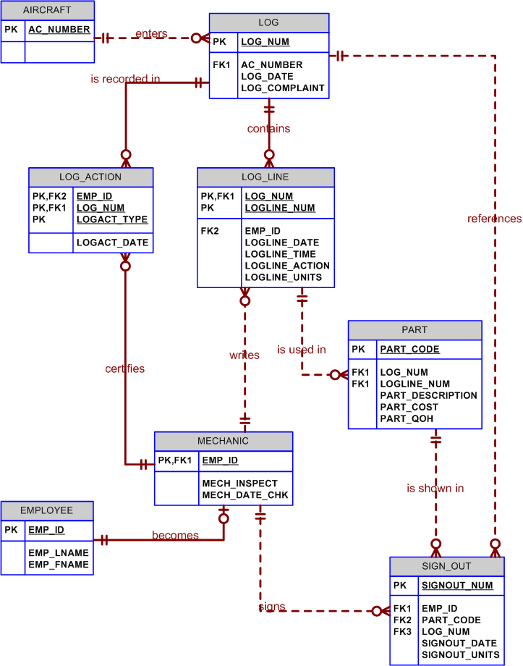
As you discuss the ERD shown in Figure PB.7D1, note its similarity to the car dealership’s maintenance section of the ERD presented in Figure PB.3a. However, the ROBCOR Aircraft Service ERD has been developed at a much higher detail level, thus requiring fewer modifications during the verification process. Figure PB.7D1 shows that:
- Each LOG entity occurrence will yield one or more maintenance procedures.
- Each of the individual maintenance procedures will be listed in the LOG_LINE entity.
- A mechanic must sign off on each of the LOG_LINE entity occurrences.
- The possible parts use in each LOG_LINE entity occurrence is now traceable.
- A part can be accounted for from the moment it is signed out by the mechanic to the point at which it is installed during the maintenance procedure.

The “references” relationship between LOG and PART is subject to discussion. After all, you can always trace each part’s use to the LOG through the LOG_LINE entity. Therefore, the relationship is redundant. Such redundancies are – or should be – picked up during the verification process.

We have shown the MECHANIC to be a subtype of the EMPLOYEE supertype. Whether the supertype/subtype relationship makes sense depends on the type and extent of the attributes that are to be associated with the MECHANIC entity. There may be externally imposed requirements – often imposed through the government’s regulatory process -- that can best be met through a supertype/subtype relationship. However, in the absence of such externally imposed requirements, it is usually better to use an attribute in EMPLOYEE – such as the employee’s primary job code – and link the employees to their various qualifications through a composite entity. The applications software will then be used to enforce the requirement that the person doing maintenance work is, in fact, a mechanic.

- You have just been employed by the ROBCOR Trucking Company to develop a database. To gain a sense of the database’s intended functions, you have spent some time talking to ROBCOR’s employees and you’ve examined some of the forms used to track driver assignments and truck maintenance. Your notes include the following observations:
- Some drivers are qualified to drive more than one type of truck operated by ROBCOR. A driver may, therefore, be assigned to drive more than one truck type during some period of time. ROBCOR operates several trucks of a given type. For example, ROBCOR operates two panel trucks, four half-ton pick-up trucks, two single-axle dump trucks, one double-axle truck, and one 16-wheel truck. A driver with a chauffeur’s license is qualified to drive only a panel truck and a half-ton pick-up truck and, thus, may be assigned to drive any one of six trucks. A driver with a commercial license with an appropriate heavy equipment endorsement may be assigned to drive any of the nine trucks in the ROBCOR fleet. Each time a driver is assigned to drive a truck, an entry is made in a log containing the employee number, the truck identification, and the sign-out (departure) date. Upon the driver’s return, the log is updated to include the sign-in (return) date and the number of driver duty hours.
- If trucks require maintenance, a maintenance log is filled out. The maintenance log includes the date on which the truck was received by the maintenance crew. The truck cannot be released for service until the maintenance log release date has been entered and the log has been signed off by an inspector.
- All inspectors are qualified mechanics, but not all mechanics are qualified inspectors.
- Once the maintenance log entry has been made, the maintenance log number is transferred to a service log in which all service log transactions are entered. A single maintenance log entry can give rise to multiple service log entries. For example, a truck might need an oil change as well as a fuel injector replacement, a brake adjustment, and a fender repair.
- Each service log entry is signed off by the mechanic who performed the work. To track the maintenance costs for each truck, the service log entries include the parts used and the time spent to install the part or to perform the service. (Not all service transactions involve parts. For example, adjusting a throttle linkage does not require the use of a part.)
- All employees are automatically covered by a standard health insurance policy. However, ROBCOR’s benefits include optional co-paid term life insurance and disability insurance. Employees may select both options, one option, or no options.

Given those brief notes, create the ER diagram. Make sure you include all appropriate entities and relationships, and define all connectivities and cardinalities.

The ERD in Figure PB.8a contains a maintenance portion that has become our standard, given that it enables the end user to track all activities and parts for all vehicles. In fact, given its ability to support high accountability standards, we first developed the "basics" of this design for aviation maintenance tracking.

Figure PB.8a The Initial Crow’s Foot ERD for the ROBCOR Trucking Service
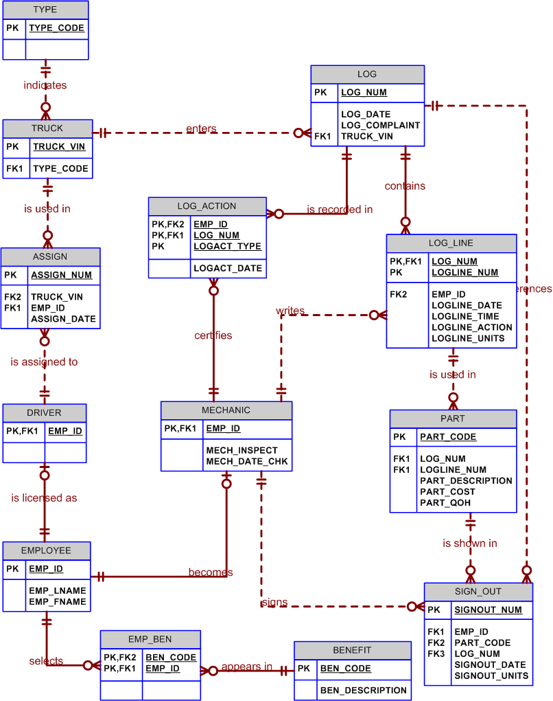

As you examine the ERD in Figure PB.8a, note that the driver assignment to drive trucks is a M:N relationship: Given the passage of time, a driver can be assigned to drive a truck many times and a truck can be assigned to a driver many times. We have implemented this relationship through the use of a composite entity named ASSIGN.

The M:N relationship between EMPLOYEE and BENEFIT – that is, the insurance package mentioned in problem 8’s last bullet -- has been implemented through the composite entity named EMP_BEN. (An employee can select many benefit packages and each insurance package may be selected by many employees.) The reason for the optionality is based on the fact that not all of the insurance packages are necessarily selected by the employee. For example, using the BENEFIT table contents shown in Table PB.8A, an employee may decide to select option 2 or options 2 and 3, or neither option. (The standard health insurance package is assigned automatically.)

Table PB.8A Table name: BENEFIT
BEN_CODE | BEN_DESCRIPTION | BEN_CHARGE
1 | Standard health | $0.00
2 | Co-paid term life insurance, $100,000 | $35.00
3 | Co-paid disability insurance | $42.50

Incidentally, we have used a BENEFIT entity, rather than an INSURANCE entity to anticipate the likelihood that benefits may include items other than insurance. For example, employees might be given a benefit such as an investment plan, a flextime option, child care, and so on.

The decomposition of M:N relationships continues to be a good subject for discussion. For example, we have shown many of the decompositions as composite entities. However, while such an approach is perfectly acceptable at the initial design stage, caution your students that composite PKs cannot be referenced easily by subsequent additions of entities that must reference those PKs. Therefore, we would note that the composite PK used in the LOG_ACTION entity -- EMP_ID + LOG_NUM + LOGACT_TYPE – should be replaced by an “artificial” single-attribute PK named LOGACT_NUM. The EMP_ID and LOG_NUM attributes would continue to be used as FKs to the MECHANIC and LOG entities. (Naturally, the EMP_ID and LOG_NUM attributes should be indexed to avoid duplication of records and to speed up queries.) A few sample entries are shown in Table

Table PB.8B Table name: LOG_ACTION
LOGACT_NUM | LOG_NUM | EMP_ID | LOGACT_TYPE | LOGACT_DATE
1000 | 5023 | 409 | Open | 14-May-2014
1001 | 5024 | 409 | Open | 15-May-2014
1002 | 5023 | 411 | Close | 15-May-2014
1003 | 5025 | 378 | Open | 15-May-2014
1004 | 5024 | 411 | Close | 15-May-2014
1005 | 5026 | 409 | Open | 16-May-2014

Finally, we have used supertype/subtype relationships between EMPLOYEE and DRIVER and MECHANIC. If drivers and mechanics are assumed to have many characteristics (such as special certifications at different levels) that are not common to EMPLOYEE, this approach eliminates nulls. However, keep in mind the discussion about the use of supertypes/subtypes in Problem B. (The use of the supertype/subtype approach may be dictated by external factors … but the use of supertypes and subtypes must be approached with some caution. For example, if drivers have multiple license types, it would be far better to create a LICENSE entity and relate it to DRIVER through a composite entity, perhaps named DRIVER_LICENSE. The composite entity may then be designed to include the date on which the license was earned and other pertinent facts pertaining to licenses. (Such flexibility is not available in a subtype, unless you are willing to tolerate the possible occurrence of nulls as more pertinent data about the (multiple) licenses are kept – if some of the drivers do not have all of those licenses.)

